**Digital Image Processing Assignment_1**

Assignment Report

Experiment Title Digital Image Processing Assignment 1

Student’s Name 蒋云翔

Student’s ID 2022102330

Class CST

Date handed in 2024/11/11

International school, Jinan University

1. **Objectives**

Design a portrait beautification system. Develop an application that can automatically beautify portrait photos by combining digital image processing techniques such as filtering, color adjustment, and enhancement.

**B. Technique**

As far as possible to GPT put forward appropriate and reasonable requirements, so that GPT can generate a reasonable portrait beautification system for me. **(Tips: I use Copilot Ai to accomplish this assignment!!)**

**C. Experiment Content**

1. Configure the required system environment

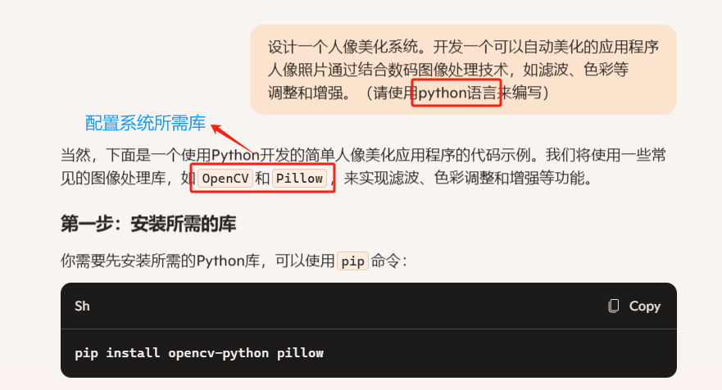

Figure 1: Build the library required by the system

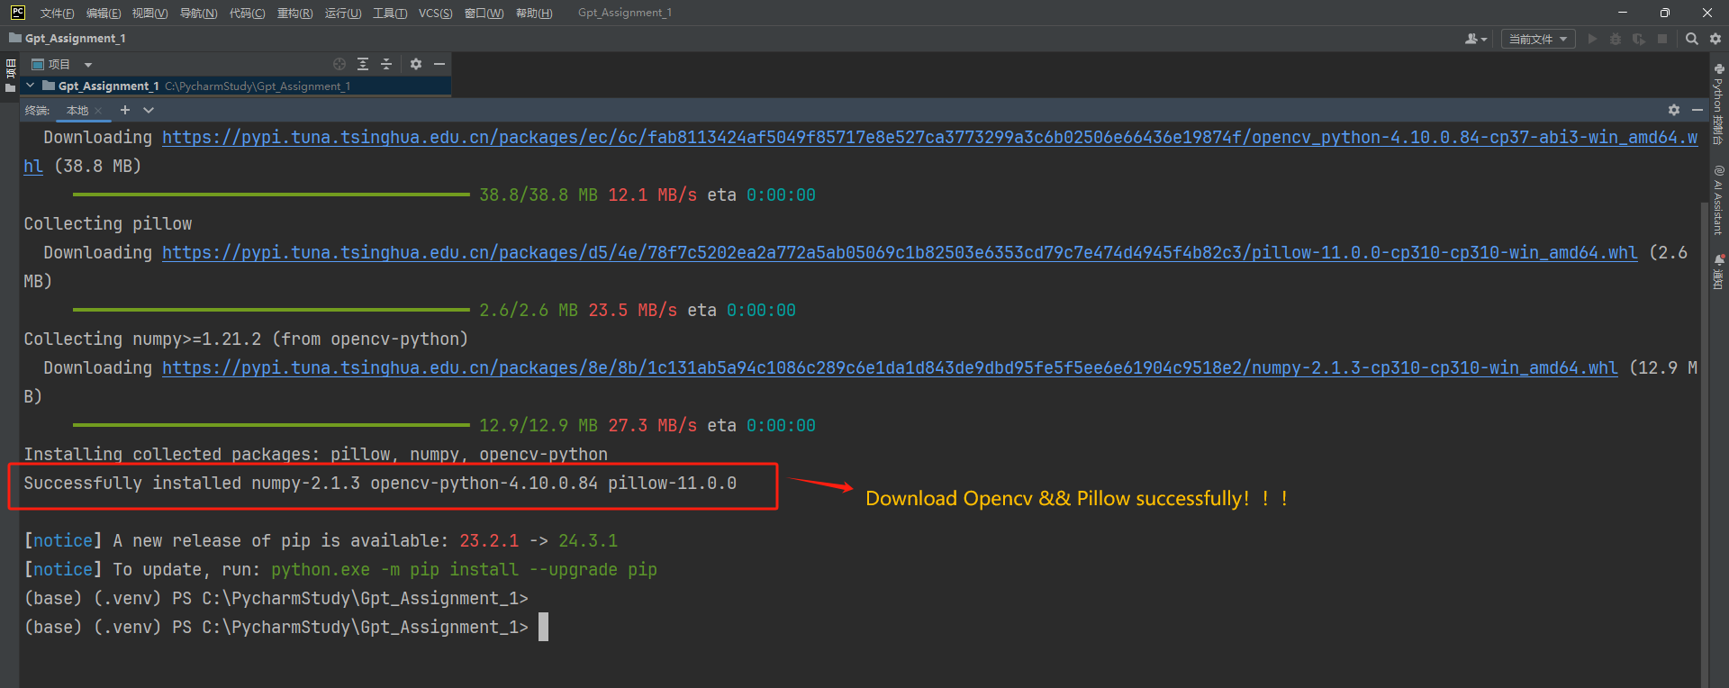

Figure 2: Build the library required by the system in python

1. Generate code framework using GPT

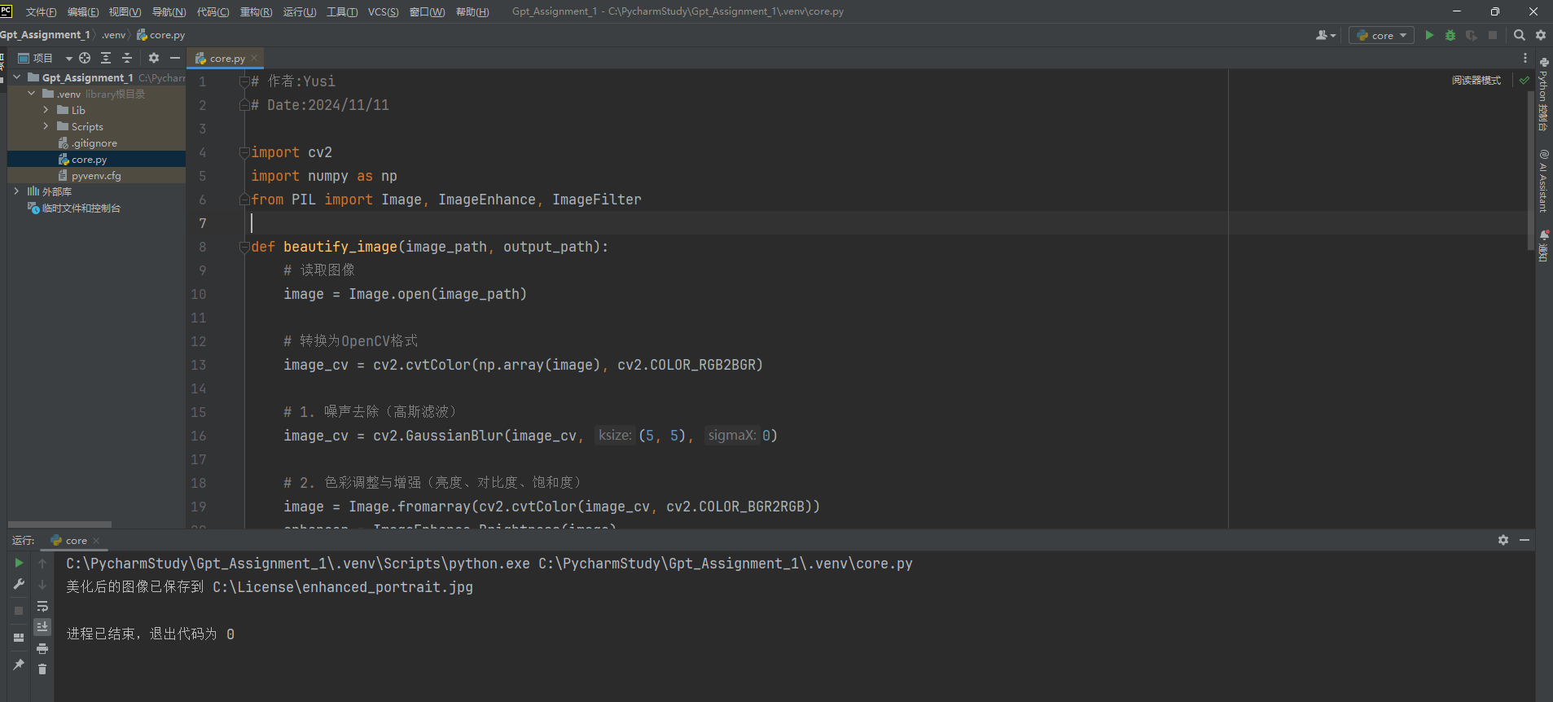

Figure 3: Implement the code in PyCharm

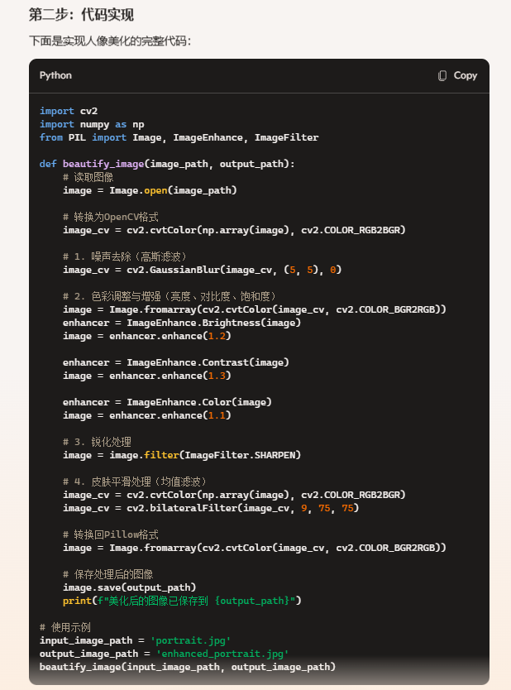

Figure 4: Implement the code in PyCharm

Note that some of this code needs to be changed, in the file path section, the absolute path of the input needs to be improved, and the same path of the output needs to be corrected

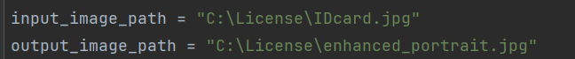

Figure 5: Modify some codes

1. Test picture examples and optimize code structure

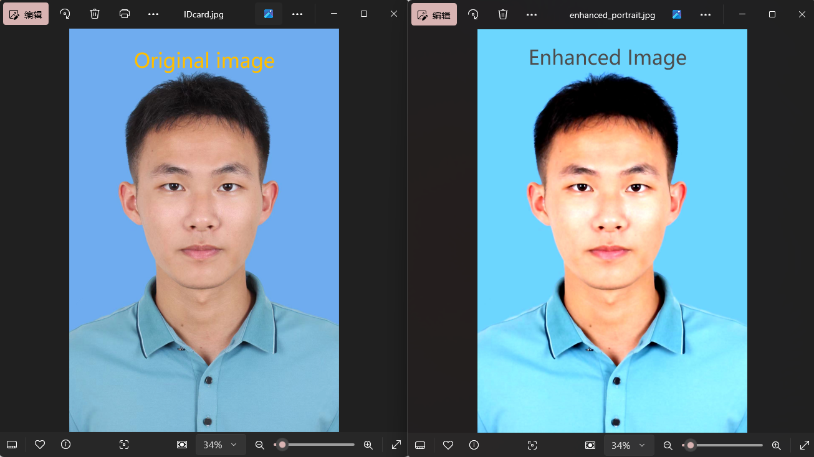

Figure 6: Test1 with my personal picture

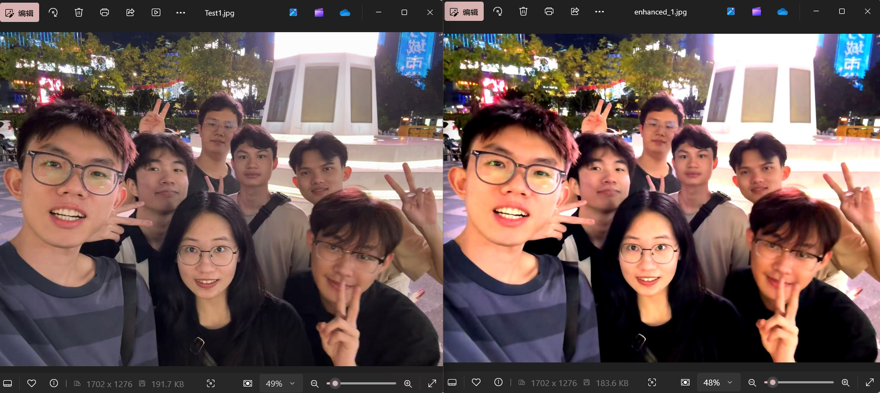

Figure 7: Test2

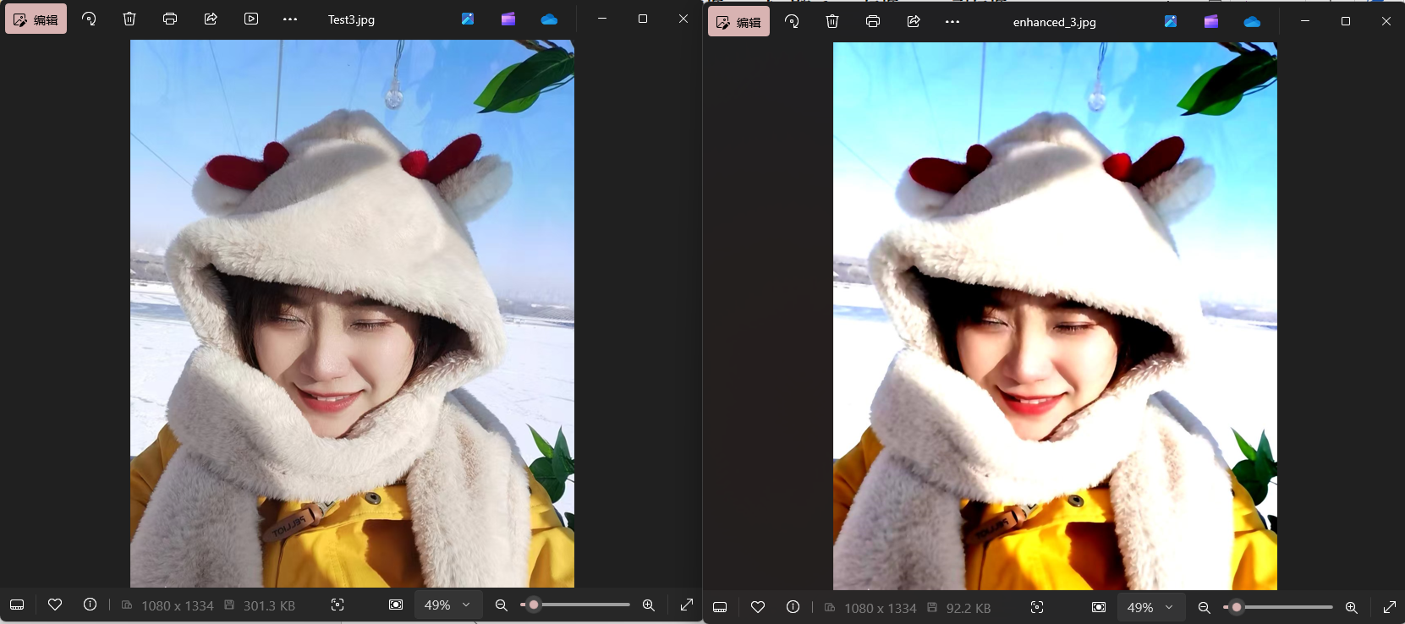

Figure 8: Test3

I used three different types of photos of myself (**male photos**)/**group photos**/**female photos** to test the portrait beautification code, and the verification results were not as good as I imagined. The brightness and contrast of the beautified pictures were high, which made the human eyes feel uncomfortable at first glance. I asked Copilot to optimize the code and was ready for the next round of testing



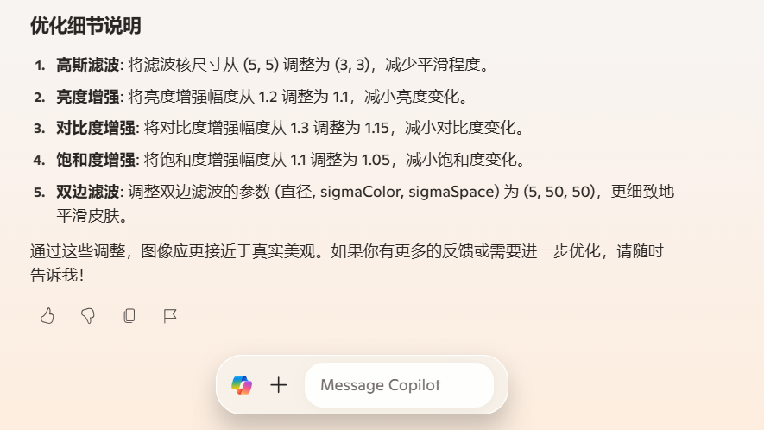

Figure 9: Continue to communicate with copilot

Next, I continue to test the new code using the three cases I tested before.

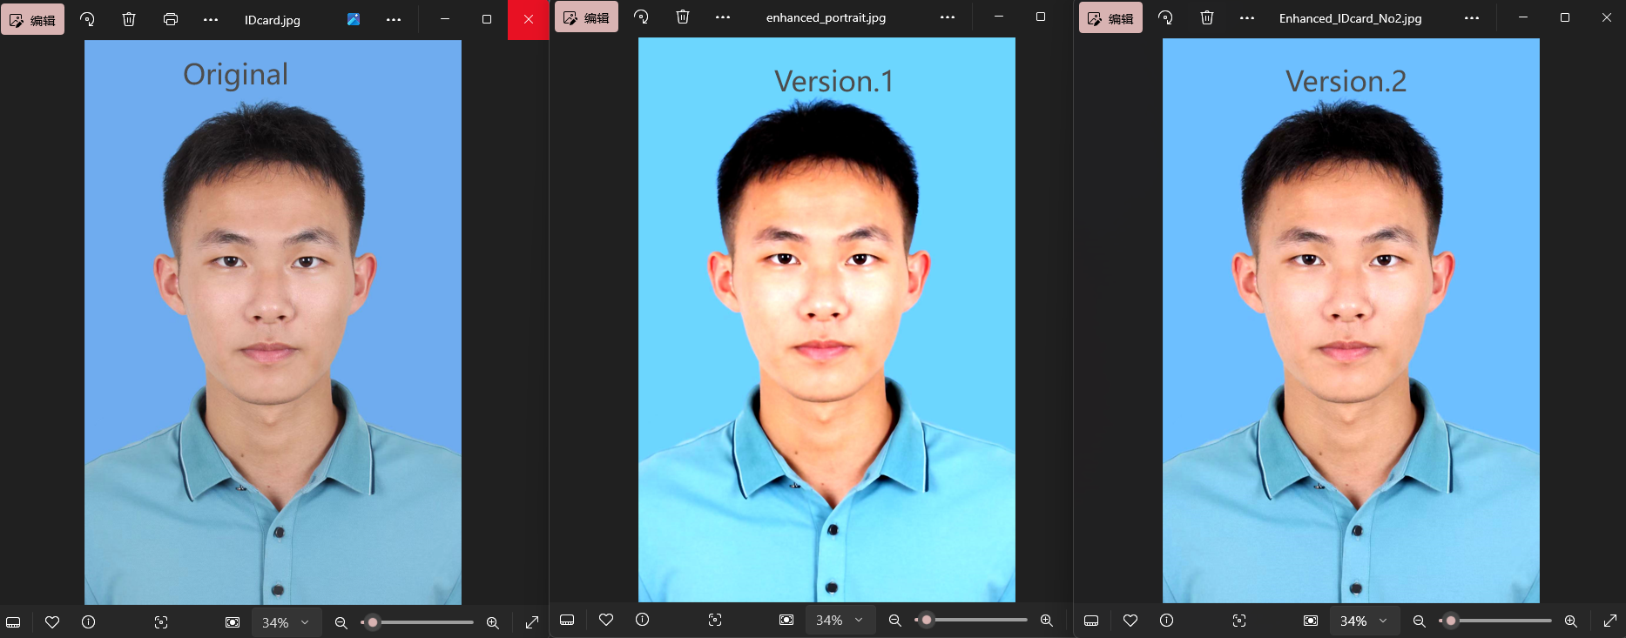

Figure 10: Test1 (Version.2)

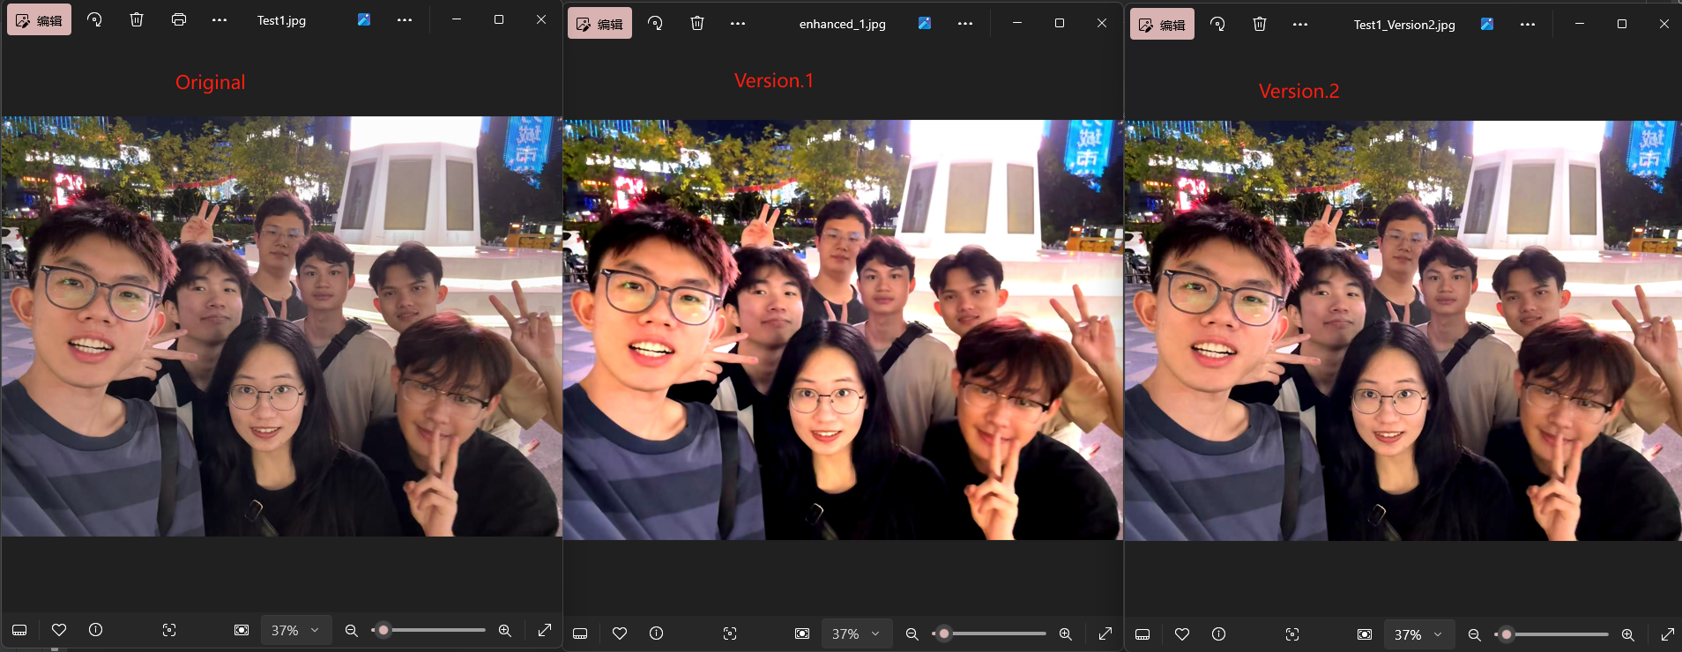

Figure 11: Test2 (Version.2)

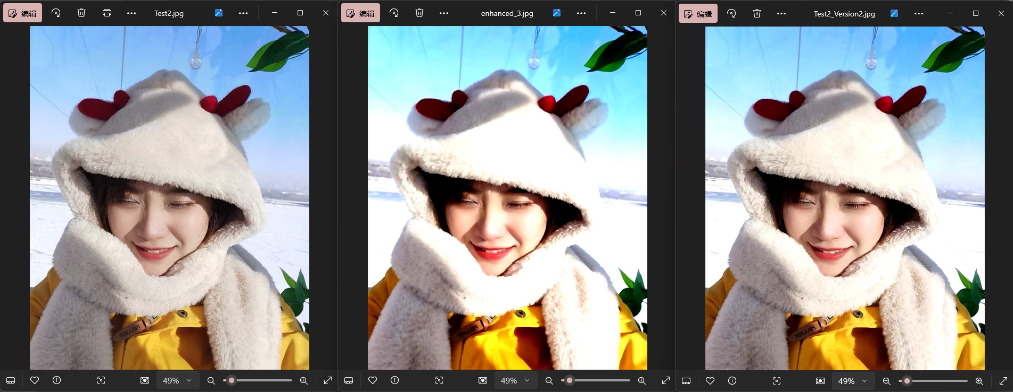

Figure 12: Test3 (Version.2)

After this round of testing, we can intuitively see that after the code is optimized (after parameter adjustment), the aesthetics of the image has been greatly improved, and the beautification effect has been successfully achieved.

1. Try to explore deeper functions or application development

The above experimental process is enough for us to simply beautify a picture, but if we want to pursue higher requirements and higher standards of beautification performance, it is obvious that we need to use deep learning methods to model, train, and finally be able to apply it in the image. Accurately identify the face part and perform specific beautification on the face, instead of just adjusting the parameters of the entire image as the code we implemented before.

So I will continue to have a conversation with copilot to elaborate on my deeper needs.



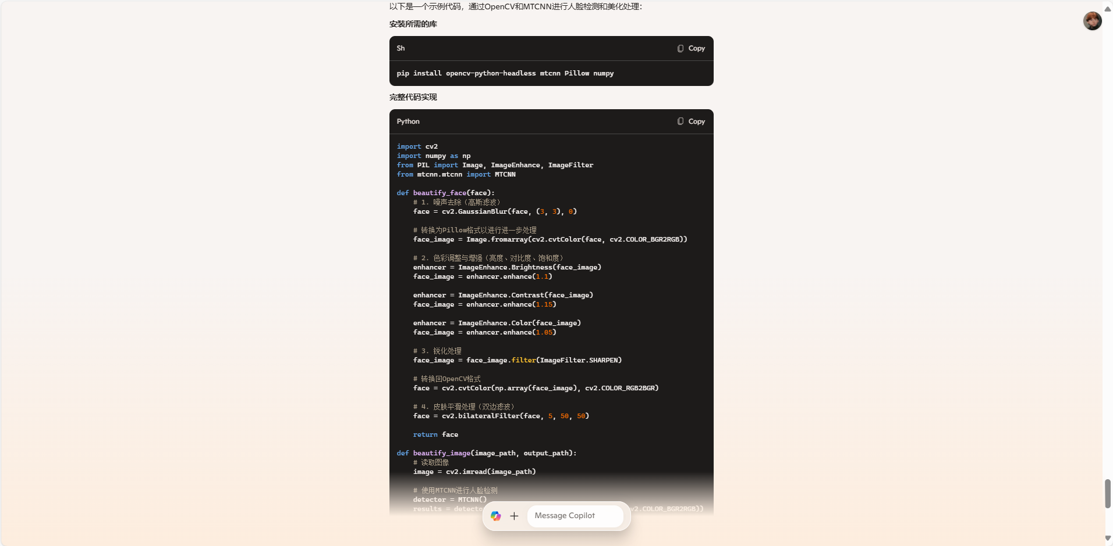

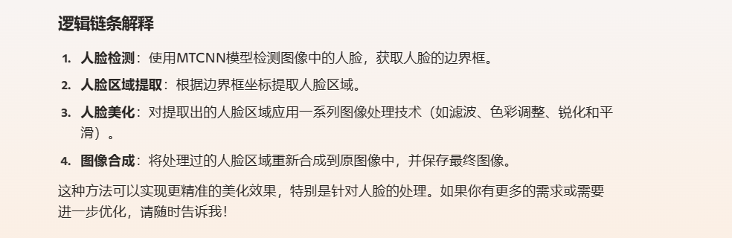

Figure 13: Continue to communicate with copilot

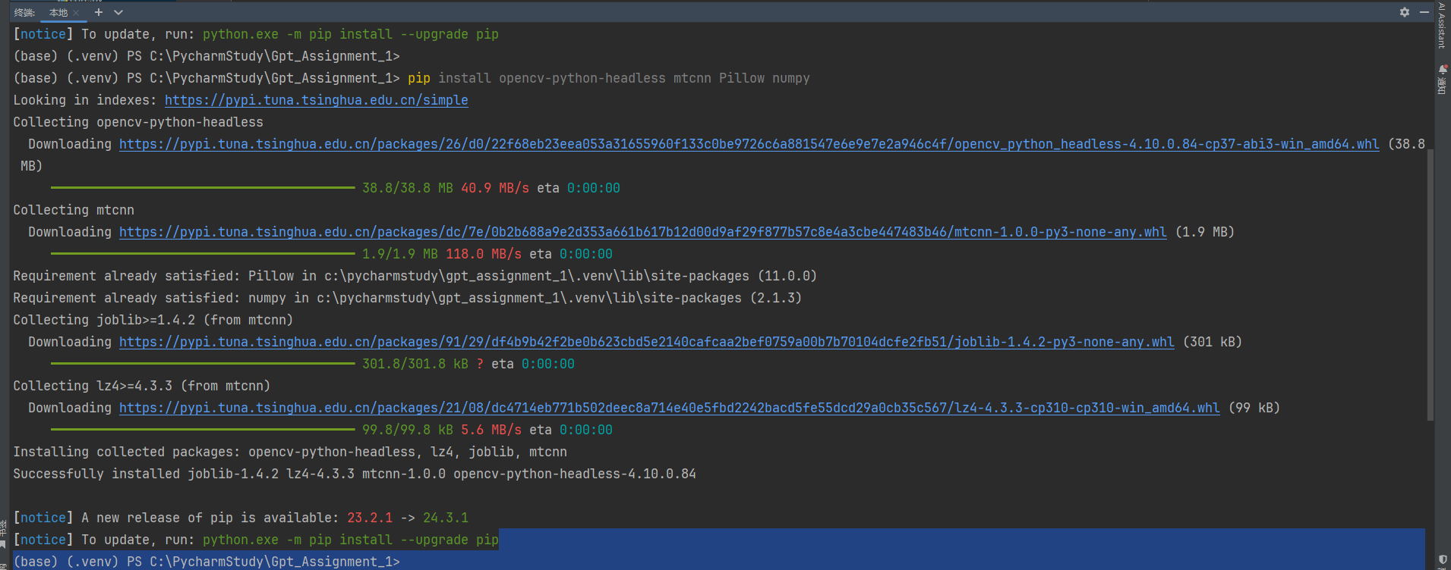

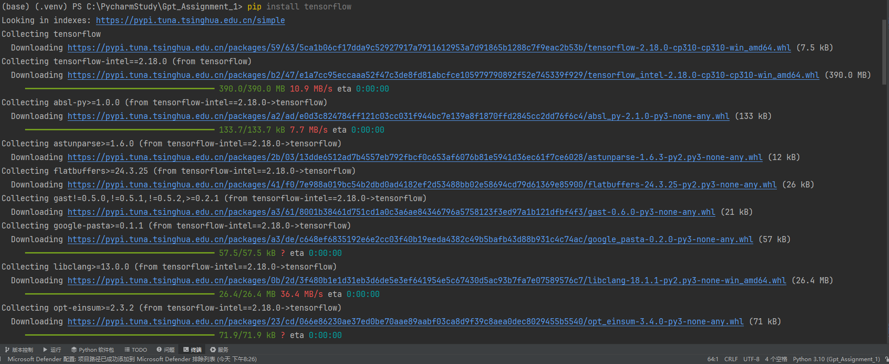

Figure 14: Build the library required by the system in python

Now let’s test the code:

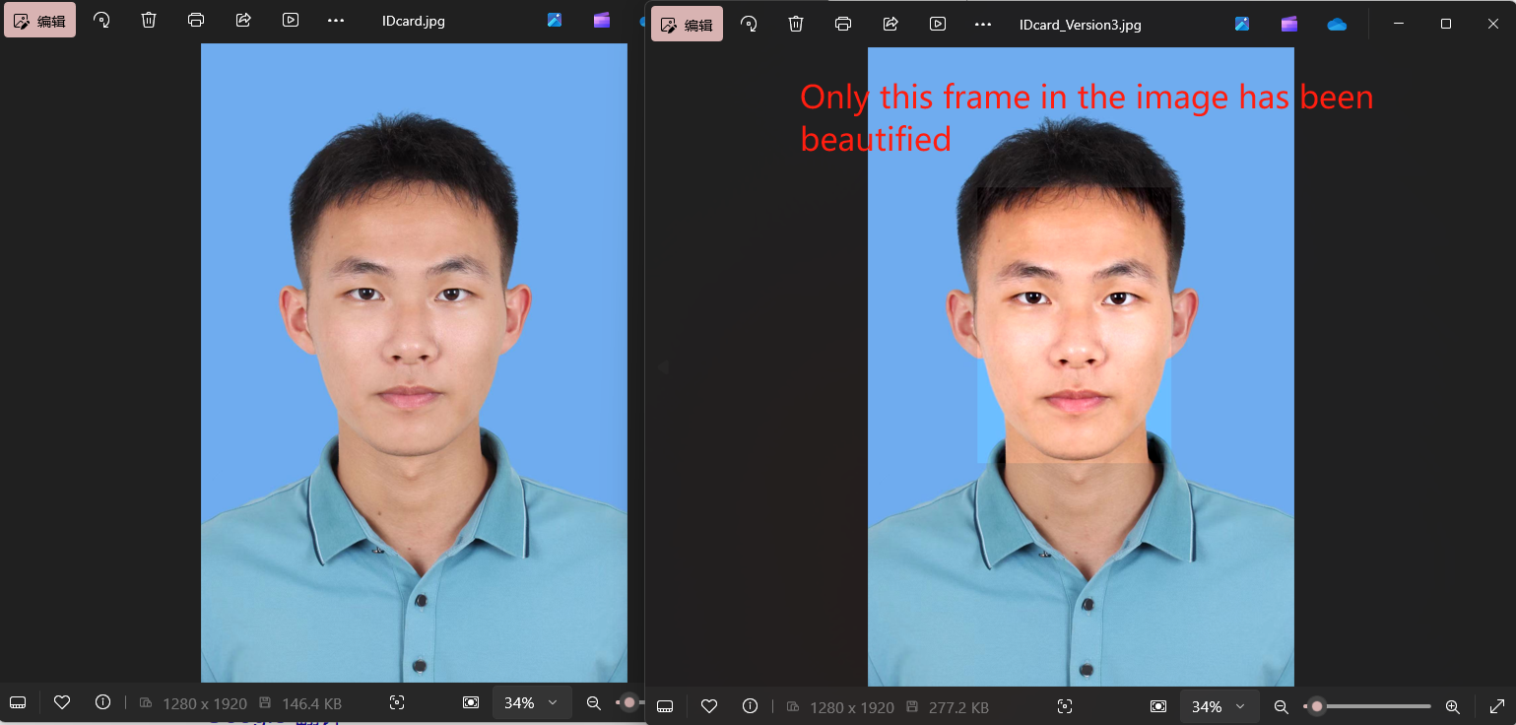

Figure 15: Test1_Version3

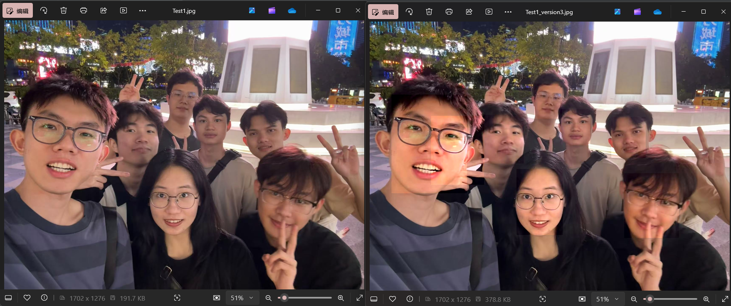

Figure 16: Test2_Version3

Happily, Copilot perfectly fulfilled my needs and only beautified the face part of the image.

**D. Conclusions**

Throughout this project, we have successfully **developed a sophisticated portrait beautification system** utilizing a combination of digital image processing techniques and deep learning. Our approach involved several key stages, beginning with basic image operations such as reading, displaying, and extracting vital information from images. This foundational knowledge set the stage for more complex tasks, including zooming, shrinking, and applying various interpolation methods to enhance image quality.

We then progressed to intensity transformations, where we employed log and power-law transformations to adjust image brightness and contrast. This experimentation allowed us to fine-tune parameters to achieve optimal visual enhancements, providing valuable insights into image enhancement techniques.

To achieve a higher level of precision in beautification, we incorporated deep learning for facial detection and feature recognition. By leveraging pre-trained models like MTCNN, we were able to accurately detect faces within images and apply targeted beautification techniques. This included noise reduction, color adjustment, sharpening, and skin smoothing, all aimed at enhancing the visual appeal of facial regions while preserving the natural aesthetics.

The result is a robust and effective application capable of automatically beautifying portrait images with high accuracy and aesthetic quality. Our system demonstrates the powerful synergy between traditional image processing methods and modern deep learning techniques, paving the way for further advancements in automated image enhancement.

This project not only showcases the technical capabilities of image processing and deep learning but also highlights the potential for practical applications in fields such as photography, digital media, and user-centric software development. We look forward to exploring additional features and improvements to further refine and expand the capabilities of this system.